OVLP Academic Year 2025-26
Duration: March 9 - 13, 2026 |  |  | Grade: Pre-Nursery |  |  | Subjects: All
Term III |  |  |  | Week: 2
 | English | Urdu |  |  | Math |  | IT | HCD
Links | class story  Tree:  https://drive.google.com/file/d/1YPejH9GCHm0rIpelgWYzrax3qNHjepIF/view?usp=sharing  The Honest Elephant:  https://drive.google.com/file/d/1lwAwKqlnQvW-hFTRBqN4f_tHvo_02jVv/view?usp=sharing  Letter r  https://drive.google.com/file/d/14q4NPRfW_VFwxlX7eFVDRP0dvqyOYDcT/view?usp=share_link  Reading Letter r  https://drive.google.com/file/d/1NkZArMA-66v5gXdH72tN7lnZgD8c49ta/view?usp=sharing | class story  Murghi or chiriya  https://drive.google.com/file/d/1l1Gdko6TYpm5cb6e8JHlenTX2PK9_s5h/view?usp=sharing  Bhalu ka bacha  https://drive.google.com/file/d/1ncUv2pL3RmwAOLrY5lHQ84rCgscjfDzj/view?usp=sharing  Ont or Saya  https://drive.google.com/file/d/1kickcOMQo0xpV-bJFEhDATb68gkuEENC/view?usp=sharing  harf yaay  https://drive.google.com/file/d/1BpPj-u0VHlKkFOeagC1OrVnZlqJOAiay/view?usp=share_link  Reading harf yaay  https://drive.google.com/file/d/1mTSXl8fZBMND1cJUelj_KW4akUxHbj6J/view?usp=sharing |  |  | Number 17.  https://drive.google.com/file/d/1WZ2gl32f3UTPhAT0EqwpDFhnrHo7Dt3F/view?usp=sharing  Reading Number 17.  https://drive.google.com/file/d/1qTqzL2Vxij2c1wuG69PQplT-eVjJ-YlT/view?usp=sharing |  | Week 2 OVLP Grade Pre-Nursery IT Term 3.mp4 | P. NTIIISRP2
Day 1  C.W | - Writing ‘r’.  - Draw picture with ‘r’.(road , ring)  - Note book pg. # 36 | 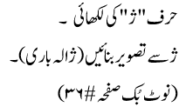 |  |  | Recognition of 17 |  |  | Pupils will learn about Sharing/Pet Animals (Revise of previous topic)
Home work | - Writing ‘r’.  - Draw picture with ‘r’.(road , ring)  - Note book pg. # 37 | __________ |  |  |  |  |  | ---------------------
Day 2  C.W | Reading of letter r. | 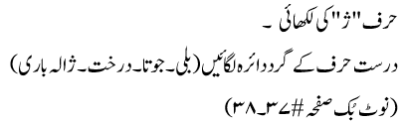 |  |  | - Writing number 17.  - Tracing of shape (Square) and first letter.  - Note book pg. # 30 |  |  | Pupils will learn about Food of the week is Lettuce.
Home work | _________ | 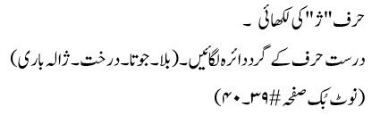 |  |  |  |  |  | --------------
Day 3 | - Writing “r”.  - Circle the correct letter of pictures (leaf, necklace, parrot, ring)  - Note book pg. # 38 | 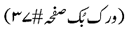 |  |  | - Writing number 17.  - Join the dots to make square shape and write 1st letter.  - Note book pg. # 31 |  |  | Pupils will be playing the game is Ring-a-ring o’ roses,
Home work | ______________ | __________ |  |  | - Writing number 17.  - Join the dots to make square shape and write 1st letter.  Note book pg. # 32 |  |  | --------
Day 4  C.W | - Write a-r.  - Circle all ‘r’.  - Note book pg. # 39 | 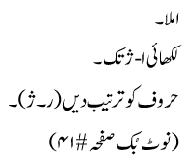 |  |  | Workbook pg. # (71-72). |  |  | Oral Questions and answers: Q 1: What is the national fruit of Pakistan? Ans: Mango is the national fruit.  Q 1: How many Eids do Muslims celebrate? Name them. Ans: Muslims celebrate two Eids. (Eid-ul-Fitr and Eid-ul-Adha).  Q 1: Tell the names of 5 pet animals. Dog, Cat, Parrot, Fish and Rabbit.
Home work | ____________ | _________ |  |  | Color 17 pencils pg. # 72. |  |  | -----------
Day 5  C.W | - Dictation.  - Write a-r.  - Note book pg. # 40 | حرف ژکی پڑھائی |  |  | - Dictation.  - Writing (0 - 17).  - Note book pg. # 33 |  |  | The revision of all the previous work done this week is complete.
 | Reinforcement  OGA will be taken. |  |  |  |  |  |  | ---------------

